TASMOTA INSTALL ON ESP DEVICE

Note when needing to modify, just connect to the i.p. address of the device.

1/ Go to tasmota.github.io/install/ Install on device, then select view webpage of the device.

Note: Tazmotixer software is only for older ESP8266 devices and won’t work with ESP32

This web software knows what the module is after programming it so then when you go to its webpage it will show the extended menu for a D1-WROOM.

2/ Configuration / module / ESP32-DevKit (1)

3/ Main menu / configuration / module

TASMOTA BATTERY MONITOR Using a D1 WROOM

Pin configurations below in Tasmota.

Pin PIO34 ( GPIO34 ) is configured as the analogue input ADC Input 3
Pin Reset is configured as the Reset Input
Pin PIO33 ( GPIO33 ) is configured as the Deep Sleep Input

Resistors ( +12v 270K A2 27K Gnd

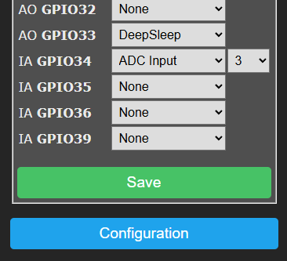

4/ configuration MQTT Parameters. Set host 172.20.7.200, port 1883

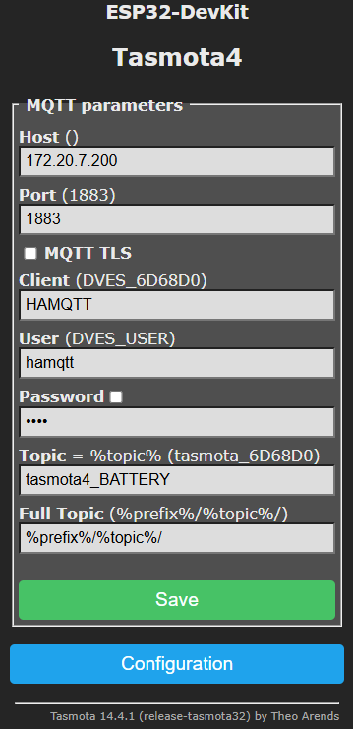

5/ configuration / other

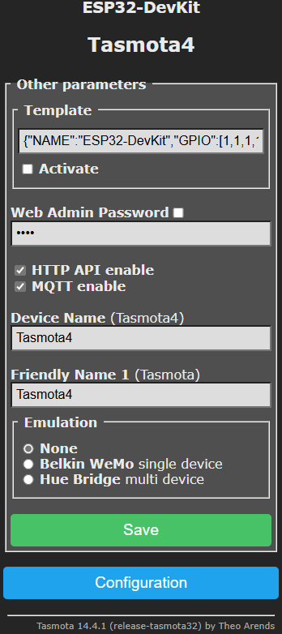

6/ Next configure the logging screen to set the telemetry time. Typically maybe set to 1 hour

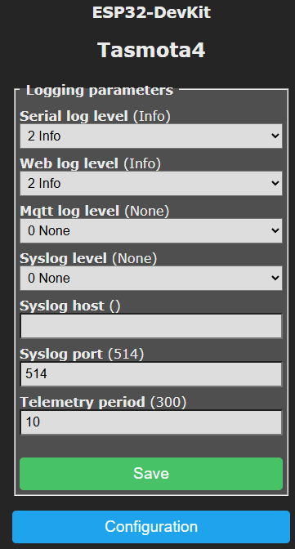

7/ Once this is done go to HASS Tasmota and the device should be discovered. Notice the name Tasmota4 and also the ANALOG A3 which corresponds to the configuration above.

8/ Make sure to fix i.p. address in Unifi

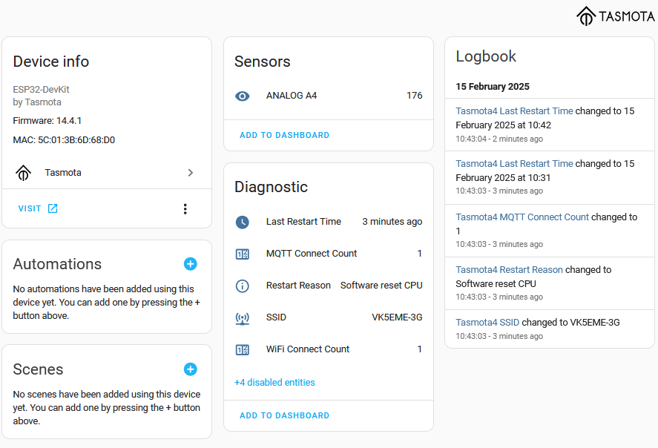

8/ In HASS templates.yaml. add the new code

- name: "Car Battery Monitor 4"
unique_id: fb0444ee-e64a-4602-adff-1df34b25a99d ( right click mouse to generate new uuid )
icon: mdi:car-battery 4
unit_of_measurement: "VDC"
state: >
{{ ((states('sensor.tasmota4_analog_a4')|float(0) - 50 ) / 107)|round (2) }}

Time set to 5 minutes 300 and data to 60 seconds

8/ Don’t forget to then restart HASS so that the code above is activated so then show the car battery monitor 4 output in volts.

9. If you cannot see the volts being updated or reading 0.47 etc. Check the

{{ ((states('sensor.tasmota4_analog_a4') and make sure that it is exactly correct spelling of the sensors name.

9/ in main menu / tools / console Set the sleep mode. DeepSleepTime 300 For off = DeepSleepTime 0

Below for WEMOS D1 did not work as sleep function seems faulty due to onboard RAM

There are three ways to revive from (deep) sleep;
- You can press the reset button
- You connect RST and GND with a switch (effectively the same as a RST button)
- You can use the inbuild sleep function
The inbuild Deep sleep function uses GPIO16 as an Output which is ether HIGH (3.3 V) during sleep or LOW (0.0V) once the timer has finished.
Connecting D0 (GPIO16) directly to RST as per original manual will result in a constant 3.3 V on RST while in sleep and prevents a manual or software reset to pull LOW. Uploading firmware is apparently not working either (not tested this myself).
To fix these issues you can either use a resistor lower than 350 Ohm or better, a diode between RST and D0 (pointing to D0 ).
A diode or resistor will prevent 3.3 V on RST while D0 is HIGH during deep sleep thus allowing a manual RST through USB-TTL or the RST circuit. It is also preventing damaging the chip if the RST is pulled down through UART chip when booting up. Apparently the problem is that during during Linux Kernel boot phases 1-3 all pins are floating (GPU to CPU handover) and on Phase 4, the PINs are set to the correct state. Connecting D0 and RST directly can result in a fired WEMOS.
Using a higher resistor might work when your battery is full but might not work once your battery is running lower. I am using a normal diode (not a Schottky) and this works great so far. However, I have not done any testing over a longer period. I will do soon and update once I know more.

1/ Connect the Wemos D1 and then use the windows Tasmotizer software for intial setup. Select release, then select tasmota-sensors.bin

Click Tasmotise

2/ Use Iphaone wifi to connect to the device then open the browser. Change the wifi to my local wifi.

3. Find the i.p. address of the device and open browser window to configure. Setup the module parameters A0 GPIO17 to ADC input.

4. Go through all the settings windows below.

5. If you set the logging to be fast i.e. 2 seconds then it will disconnect from the wifi all the time.

6. MQTT explorer software can also be used to connect to HASS to see what is going on with MQTT data.

DeepSleep Algorithm General Timing~
Let's assume you have set DeepSleepTime 3600 (one hour) and TelePeriod 60 (one minute). The device will first wake at 8:00 am. The device will boot and connect Wi-Fi. Next, the correct time must be synchronized from one of the NTP servers and initial telemetry is sent.
DeepSleep is then triggered after the next TelePeriod event. In this example, it will occur after one minute. Telemetry will be collected and sent (e.g., via MQTT) and DeepSleep can happen. First, Offline is published to the LWT topic on MQTT. It then calculates the new sleeping time to wake-up at 9:00 am (3600 seconds after the last wake-up). At 9:00 am this same sequence of events happens again.
If you want to minimize the time that the device is in operation, two special values for TelePeriod exist: 10 seconds and 300 seconds. Using either of these two exact values will prevent waiting for the next telemetry. DeepSleep will be triggered within a few second of the time being synchronized rather than waiting for the TelePeriod.
To take the device out of deep sleep so that you can once again connect to the wifi, disconnect and reconnect the power. The enter DeepSleepTime 0

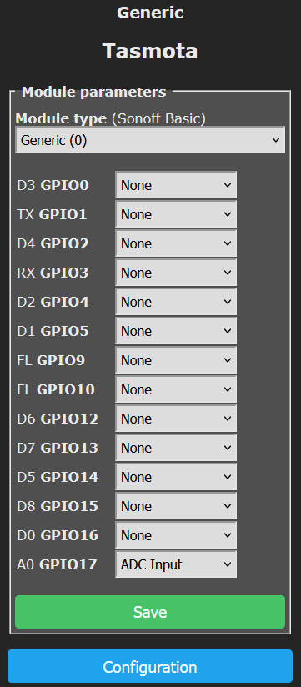

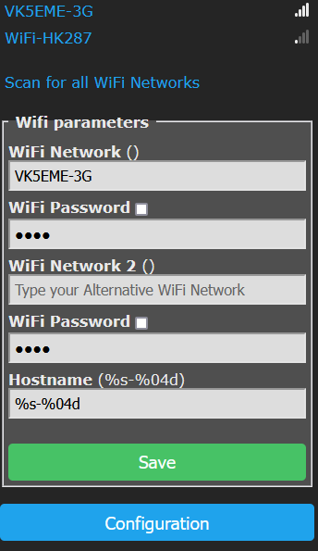

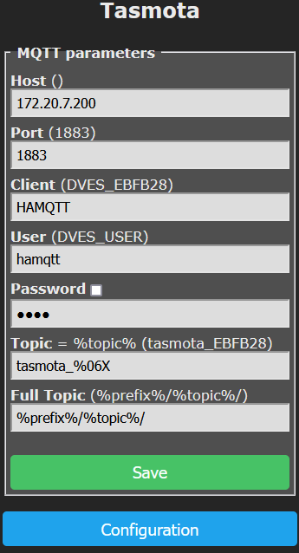

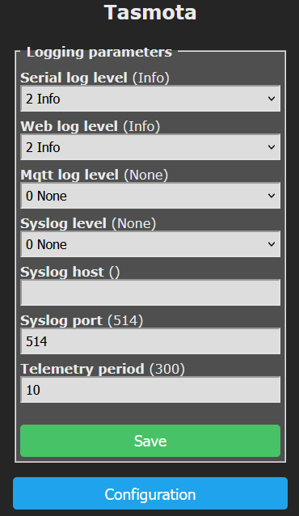

Tasmota windows software to configure.

First setup

Here is a template example for home assistant as requested

template:
- sensor:
- name: "Car Battery Monitor"
unit_of_measurement: "VDC"
state: >
{{ ((states('sensor. tasmota_analog_a0')|float(0) - 45 ) / 918 * 3.3)|round (2) }}

12 | 778 | 781.6793893 | -3.68 | 12.00
15.72 | 1024 | 1024 | 0.00 | 15.72
Start by putting 0 ‘Actual V’ in, and ensuring you get a 0 in the Tasmota output screen. Then ramp the voltage up while watching the Tasmota output. Once it reaches 1024 (assumed max number for the sensor) read the voltage, and put it in the Actual voltage column at the bottom.
Now create the second table as below from column G:
Formula
Maximum Analog0 Wemos number | 1024 | a
Voltage detected at that number | 15.72 | v
Formula (a/v) | 65.13994911
Reference the voltage field (=A6) in the ‘Voltage detected…’ column and add the formula =H2/H3 to divide the 1024 by the voltage.
Now put the voltage up to 5, and input the number in the ‘Detected A0…’ column in the left table, mine was 317. Do the rest of the columns, I added 5, 10, and 12 but the more the merrier (more accurate).
The calculated formula in column ‘Calculated by formula’ is =A3*$H$4
Difference (error) column should be =A3*$H$4
Reverse Voltage REAL Test should be =C2/$H$4
Hopefully not too confusing.
With those figures, it’s possible to add entries to ‘configuration.yaml’ with lines like the following, pasting the formula after the float value:
- sensor:
- name: "SolarBattery5"
unit_of_measurement: "V"
state: >
{{((states('sensor.solarbattery5_analog_a0')|float) /65.1399491) | round (2)}}

I couldn't find anything on the market that would monitor a 12v battery and let me integrate it into Home Assistant so I could monitor the state of the car battery when its in the garage. I decided to have a go at making my own using a NodeMCU ESP8266 board that is flashed with Tasmota, an Arduino Voltage sensor and a 12V to 5V DC-DC converter. I also designed a case for it and 3D printed it out. overall it works great. Components were sourced from Ebay but are readily available on the internet for relatively little money. I think the whole project was done under £20. This can also be done much cheaper if you broke it down into single components and soldered them all together. I flashed the NODE MCU using Tasmotizer and a USB lead from the PC straight into the unit. It was very straight forward, I used the Sonoff Basic firmware and then configured it to a generic module. There are loads of tutorials on the internet about doing this but if you are stuck with anything please just ask. Home Assistant configuration is shown later in the video, this assumes you have Home Assistant setup and working on your network, if you dont you should take a look, its brilliant!

TASMOTA BATTERY MONITOR Using a D1 WEMOS PRO3

Module type Generic (0)

Pin configurations below in Tasmota.

Pin A0 is configured as the analogue input ADC Input
Pin Reset is configured as the Reset Input
Pin GPIO14 ( GPIO14 ) D5 is configured as the Deep Sleep Input

Resistors ( +12v 270K A2 27K Gnd

